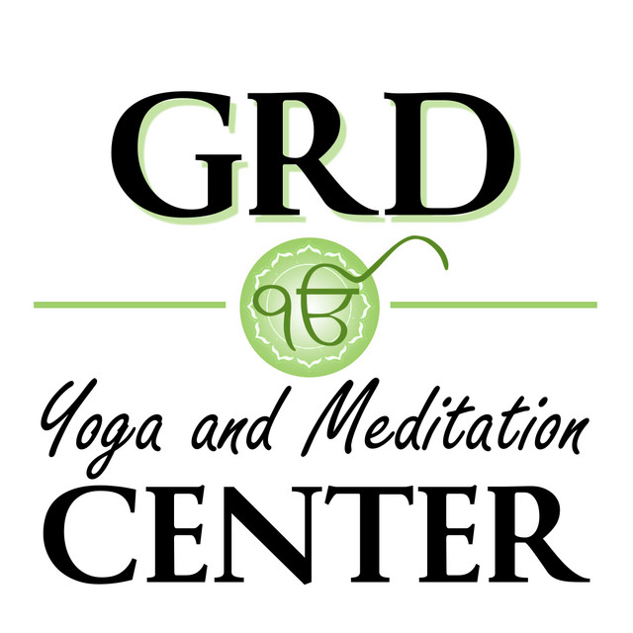

Welcome to

GRD YOGA AND MEDITATION CENTER

Please Print Legibly
Last name First name Middle name
Primary phone secondary phone
 |  |  |  |  |  |  | - |  |  |  |  |  |  |  |  |  |  |  |  |  |  |  |  |  | -
street address city state
birthday (mmddyy) Spiritual Name (if you have one) zip code
emergency contact Emergency phone number
-
EMAIL ADDRESS

To help us evaluate our marketing please tell us where you first heard about GRD Yoga and Meditation Center?
◻ Our website ◻ Our sign ◻ Our flyer
◻ Internet (other than our website – please tell us where) ____________________________________________________
◻ Friend (Name)_______________________________ ◻ Professional (Name)_____________________________
◻ Teacher or other Yoga center (Name)____________________________________________________________
◻ Other (please tell us where) _______________________________________________________________________

Release and Waiver of Liability

I agree that GRD Yoga and Meditation Center and Mukta Khalsa (GRD) is in no way responsible for the safekeeping of my personal belongings while I attend class. I am aware that GRD is here to serve me by sharing knowledge of Yoga and health. I understand that the practice of Yoga involves physical movement and exercise which may from time to time be strenuous, and that such practice carries some risk of injury. I understand that it is solely my responsibility to not injure myself through some exercises that exceed my personal limits with respect to practicing Yoga at GRD. I understand that it is my responsibility to consult with a physician prior to and regarding my participation in Yoga class. I represent and warrant that I am physically fit and I have no medical condition that would prevent my full participation.

I agree to indemnify and hold harmless GRD, its officers, directors, employees, agents, or volunteer staff from and against all claims, actions, demands, proceedings, liabilities, cost and expenses, including reasonable attorney’s fees, which they may have ascertained against or incurred by them based upon my activities or in any way related to the instruction I receive in Yoga or related subjects.

I agree that I, my heirs, assigns or legal representatives will indemnify and hold harmless GRD, or any of the aforementioned parties for any injury, property damage/loss, or death caused by their negligence or other acts. I also give my permission to appear in photographs and videos that may take place during the course of the Yoga class.

I have read the above release and waiver of liability and fully understand its contents. I voluntarily agree to the terms and conditions stated above.

SIGNATURE (LEGAL NAME): DATE:

GRD Yoga and Meditation Center, 155 Classic Cove, Atlanta, GA 30350

